**Basic Programming**

**Practicum Report**

Job sheet 7

LOOPING 2

Experiment & Assignment



Muhammad Baihaqi Aulia Asy’ari (18_2241720145)

Maulia Balqis Ansya Aulia (16_2241720246)

Hawa Esanda (11_2241720079)

INFORMATICS ENGINEERING­­

INFORMATICS TECHNOLOGY

STATE POLYTECHNIC OF MALANG

Contents

Laboratory Experiment 3

Experiment 1 3

Questions! 5

Answer! 5

Experiment 2 8

Question! 10

Answer! 10

Experiment 3 11

Question! 13

Answer! 13

Experiment 4 16

Question! 18

Answer! 18

Assignment 20

Question! 20

Answer! 21

# Laboratory Experiment

## Experiment 1

1. Experiment 1 was aimed at reviewing the loop that had been studied in the previous week. In experiment 1, a program will be made to make a view * N times sideways.
2. Create a new class, name it **Star**
3. Write the basic structure of the Java programming language which contains the **main()** function
4. Add the Scanner library
5. Make a **Scanner** declaration with the name **sc**
6. Add the following code to receive input from keyboard as the value to be stored in the variable N 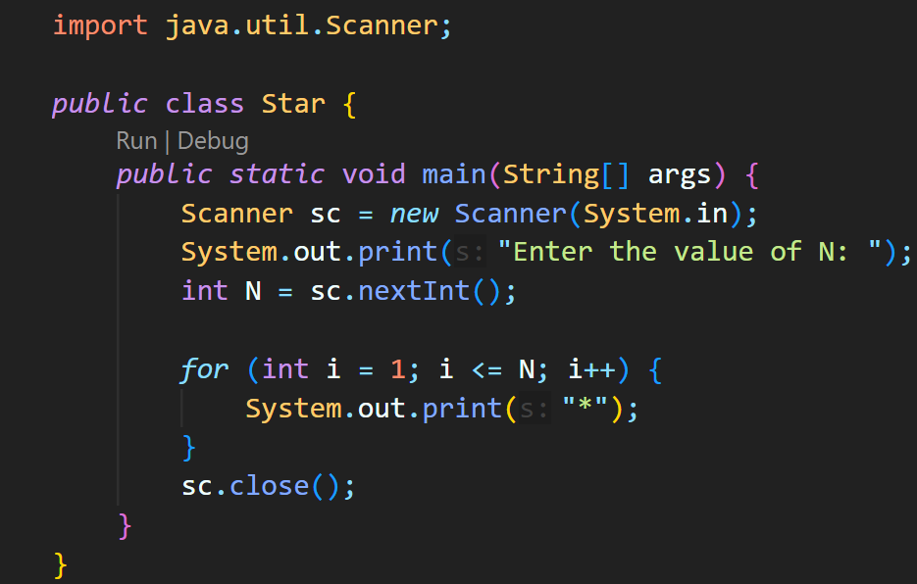
7. Add a for loop structure to display the * symbol according to the number specified via input 
8. Compile and run the program. Observe the results!
9. Match the results of the running programs that you have created according to the following display 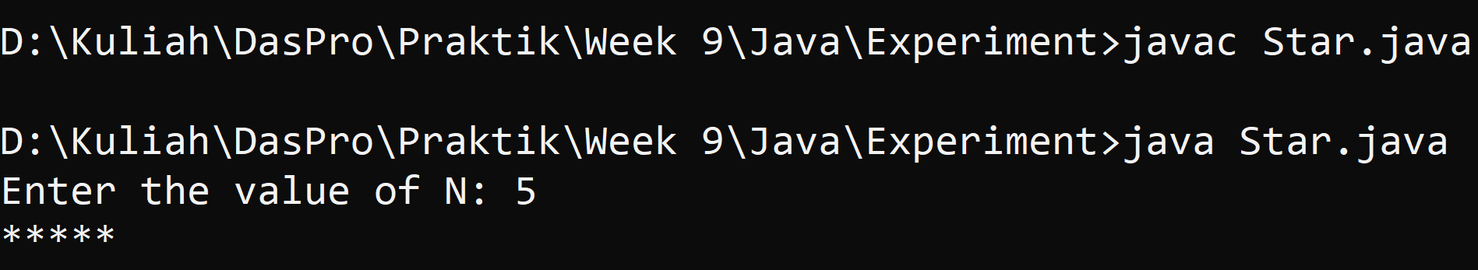 

### Questions!

1. If in for loop, the initialization i = 1 is changed to i = 0, what is the result? How can It be like that?
2. If in for loop, condition i <= N is changed to i > N, what is the result? How can It be like that?
3. If in for loop, the condition for step i++ is changed to i-- what is the result? How can It be like that?

### Answer!

1. - 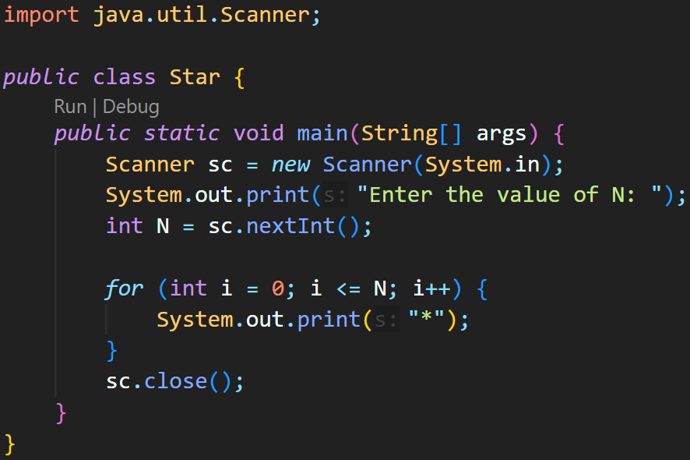 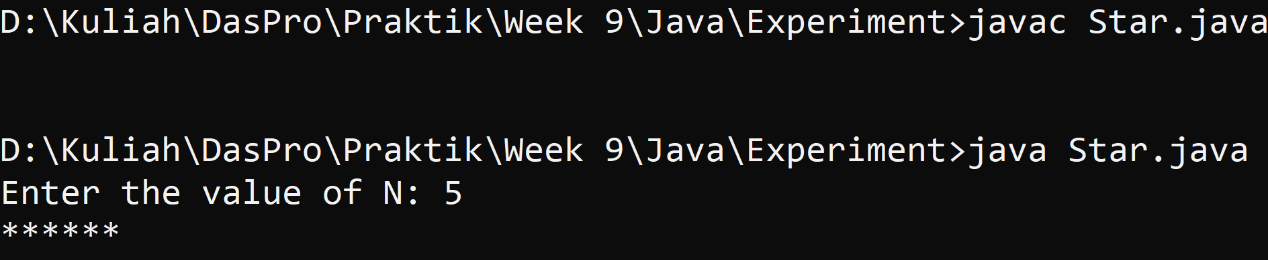
2. - 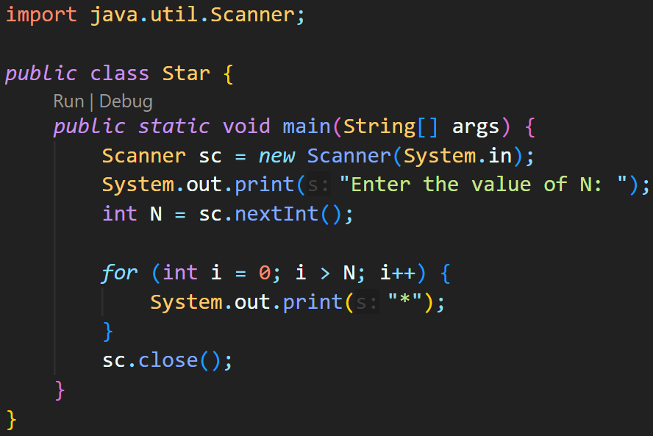 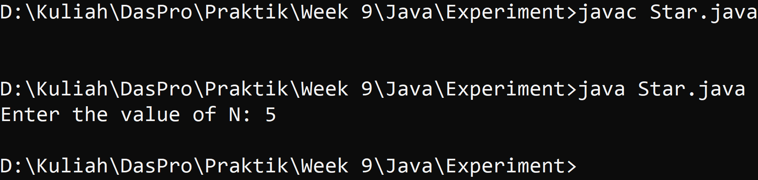
3. - 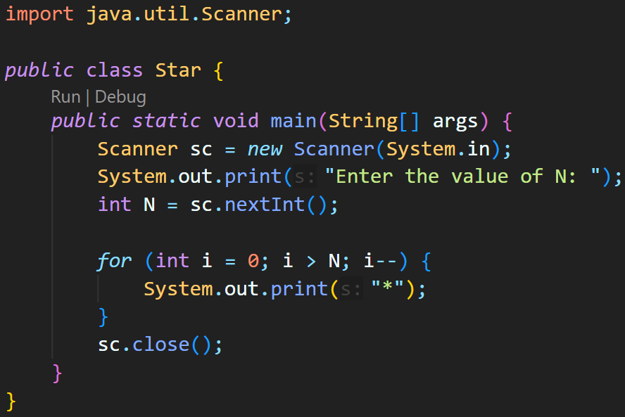 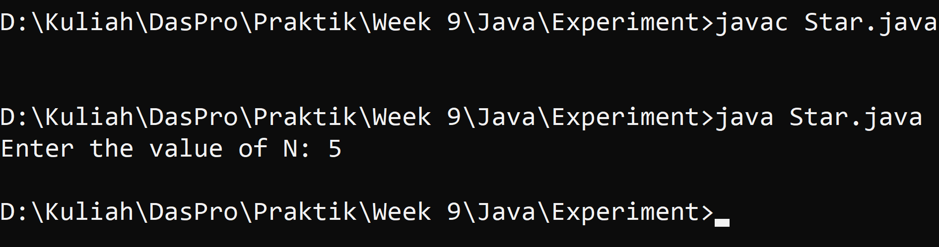

## Experiment 2

1. Experiment 2 is used to create a display * in the form of a square, with sides of a number of N. When observed further, this problem is actually similar to Experiment 1. In Experiment 1, for example the input of N is 5, then the resulting output is ***** (we can think of it as an inner loop showing 5 stars *****). For Experiment 2, doesn't the result of Experiment 1 just need to be repeated N times? (by adding an outer loop to repeat the inner loop process N times)
2. Create a new class, name it **Square**
3. Write the basic structure of the Java programming language which contains the **main()** Function
4. Add the same program code as the contents of the **main()** function in Experiment 1
5. Run the program. Make sure the results given are the same as in Experiment 1
6. Pay attention to the iterative syntax used to print * N times sideways. In step 4, we make **for** loop structure (red box) as an **inner loop**
7. Furthermore, the inner loop needs to be repeated N times in order to display the * symbol to form a square. Thus, it is necessary to add an outer loop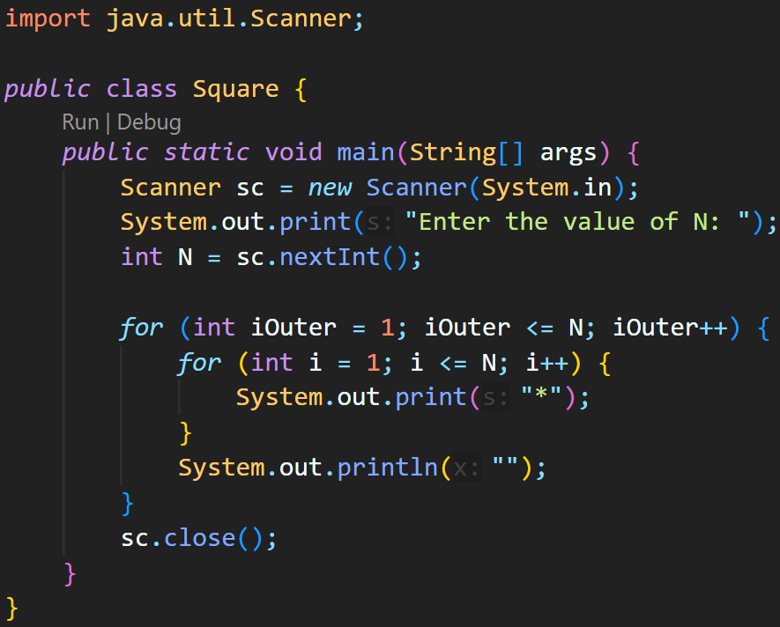
8. Compile and run the program. Observe the results! 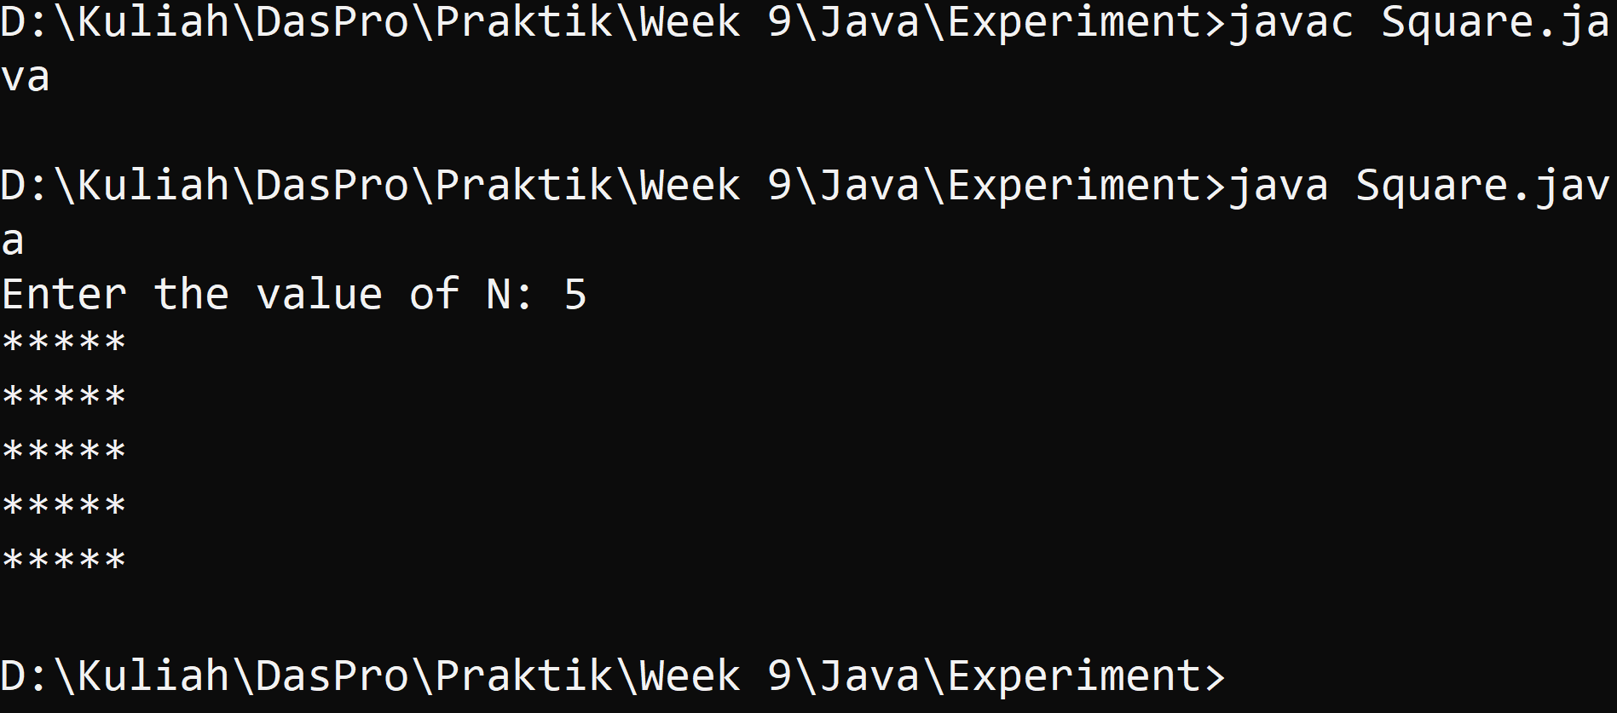
9. Match the results of the running programs that you have created according to the following display

### Question!

1. Pay attention to outer loop. If in **for** syntax, the initialization iOuter = 1 is changed to iOuter = 0, what is the result? How can it be like that?
2. Return the program to normal with initialization iOuter = 1. Then pay attention to the inner loop. If in for syntax, the initialization i = 1 is changed to i = 0, what is the result? How can it be like that?
3. What is the difference between outer loop and inner loop?
4. Why is it necessary to add the syntax System.out.println(); under inner loop? What will happen if the syntax is omitted?

### Answer!

1. Changing the initialization of iOuter from 1 to 0 would only make the for loop does an extra process adding a new line.
2. Changing the initialization of i from 1 to 0 would only make the for loop does an extra process adding a new column of stars.
3. The inner loop processes the repetition of printing stars, while the outer loop processes the repetition of printing new line.
4. Because the S.O.P is the one that prints the new line, otherwise it won't print a new line, and the stars would only be printed in a row.

## Experiment 3

1. Experiment 3 is used to create a display * in the form of a right triangle with a height of N
2. Create a new class, name it **Triangle**
3. Write the basic structure of the Java programming language which contains the main() function
4. Add the Scanner library
5. Make a **Scanner** declaration with the name **sc**
6. Add the following code to receive input from keyboard as the value to be stored in the variable N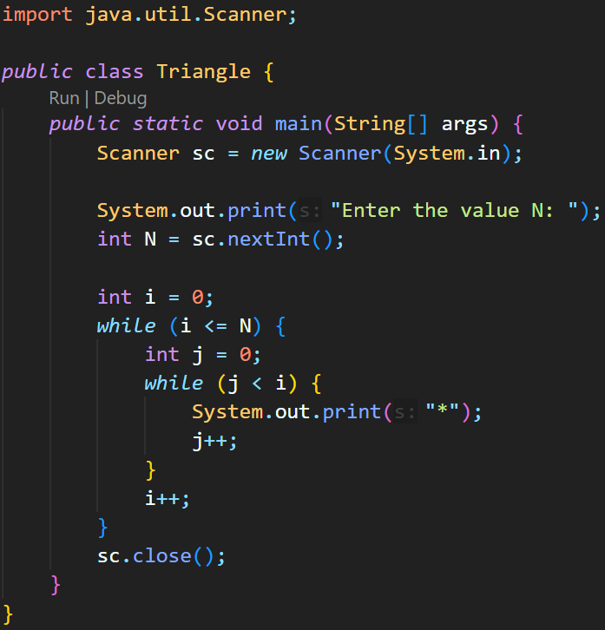
7. Add a while loop structure to display the * symbol according to the number specified via input
8. Compile and run the program. Observe the results! 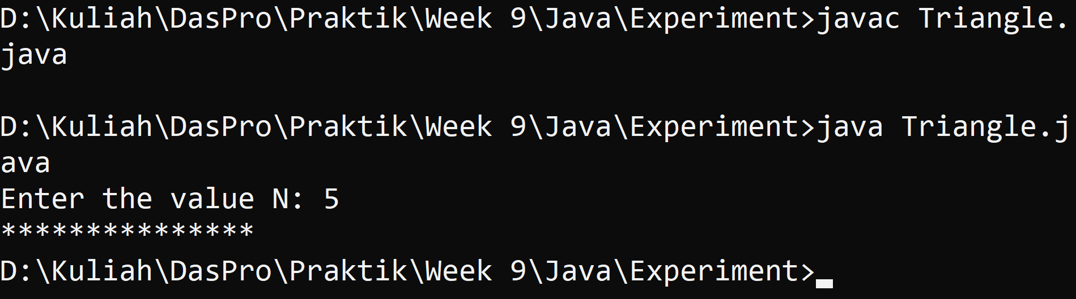

### Question!

1. Look at the results, is the output generated with a value of N = 5 in accordance with the following display?

*

**

***

****

*****

1. If not, which parts should be improved or added? Describe any parts that need to be improved or added!

### Answer!

1. No, because there is no S.O.P which make the output becomes a straight line of '*'.
2. S.O.P should be added before the placement of i++ inside the outer while loop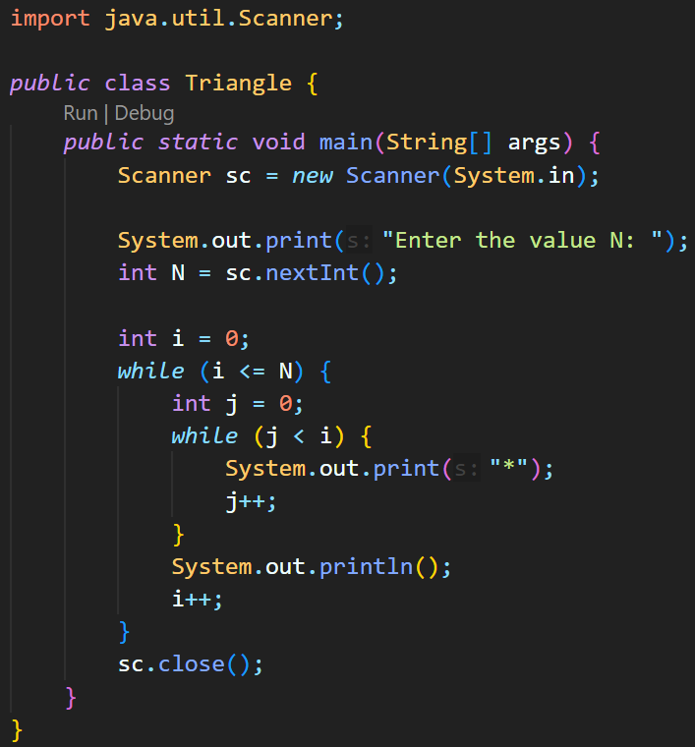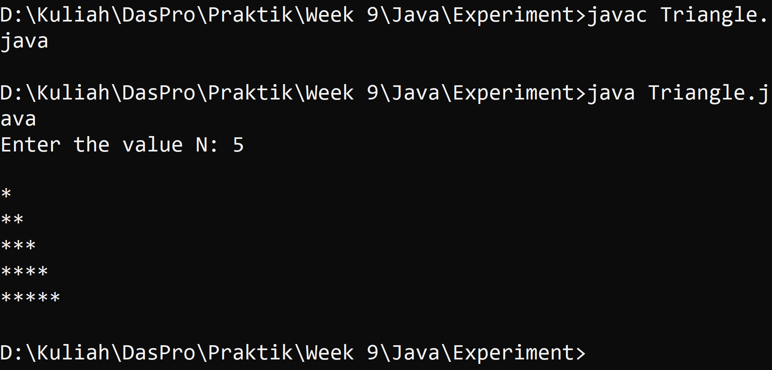

## Experiment 4

1. Experiment 4 is used to create a quiz to guess a random computer set number
2. Create a new class, name it **Quiz**
3. Add Scanner and Random libraries outside the class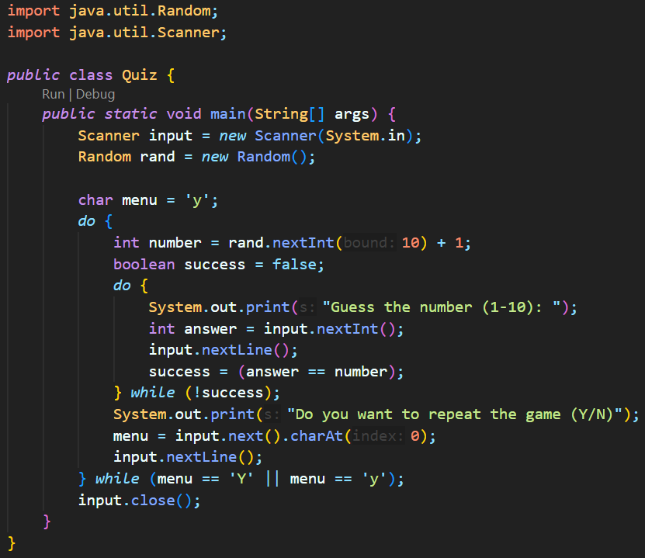
4. Write the basic structure of the Java programming language which contains the main() function
5. Make a **Scanner** declaration with the name **input** and **Random** declaration with the name **rand**
6. Add the following code to create a do-while loop structure that is used to make a game of guessing numbers quiz. In inner loop, the loop is used to ask the user to enter a number as long as the number entered does not match the number determined by the computer randomly. While the outer loop is used to repeat the game by choosing a new random number **Note**: the input.nextLine() syntax in that snippet is used to ignore the new line character
7. Compile and run the program. Observe the results! 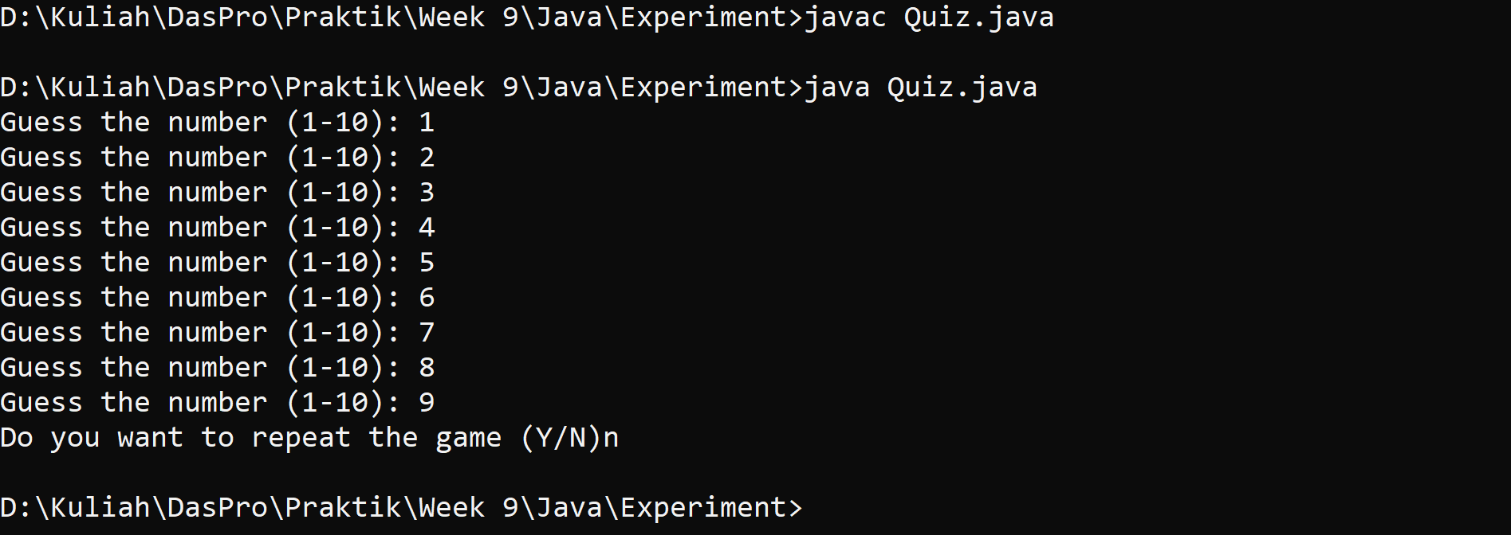

### Question!

1. Explain the program flow in Experiment 4!
2. What must be done to discontinue (not repeat) the game?
3. Modify the program above, so that it can display information about: input the guess value entered by the user, whether it is smaller or greater than the answer (number) randomly determined by the computer

### Answer!

1. Import the Scanner and Random for input and RNG. declaring a class and p.s.v.m. defining the input and RNG variable. setting the menu char to 'y' so that the outer do-while condition is met before running the program. inside the outer do-while loop the integer number is declared with a random number within a range of 1-10. the boolean success is declared as false so that the inner do-while loop condition is met before running the program. the inner do-while loop asked for input to guess the random number and check whether the input number is correct. if it is correct, it would break the inner do-while loop. After that, the program asked if the player would want to play again, if the input is 'y' or 'Y' it would loop again from the top, otherwise, it would break the loop and close the program.
2. input anything that doesn’t starts with letter y
3. -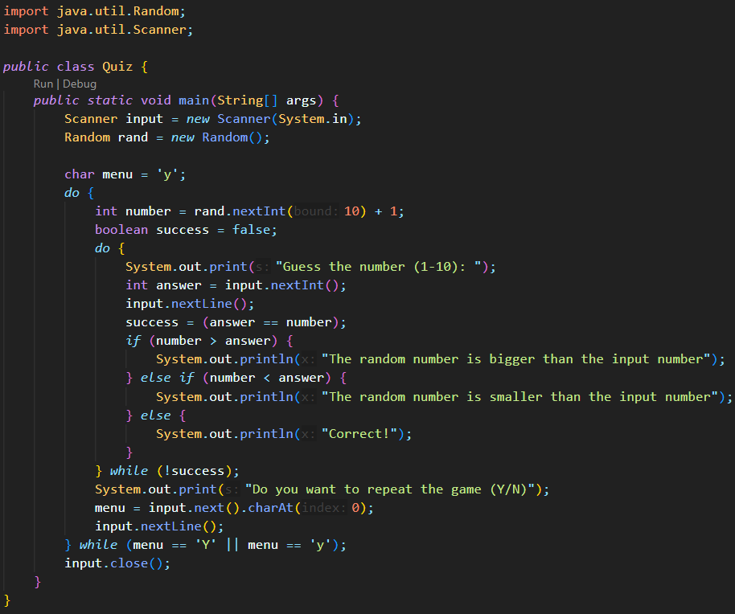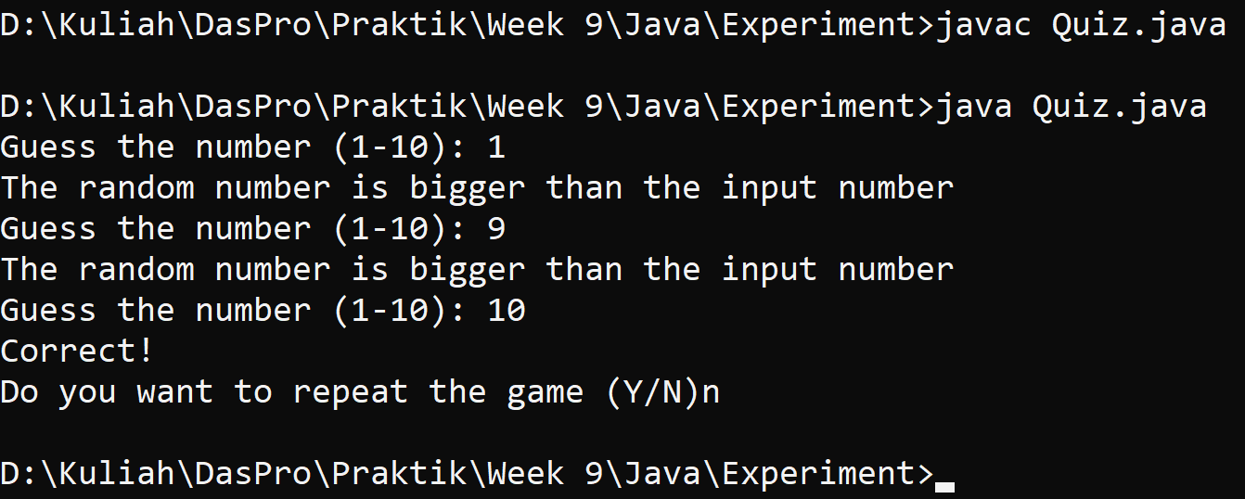

# Assignment

## Question!

1. Create a program to print a numeric triangle display as below based on the N input (minimum N value is 3). Example N = 5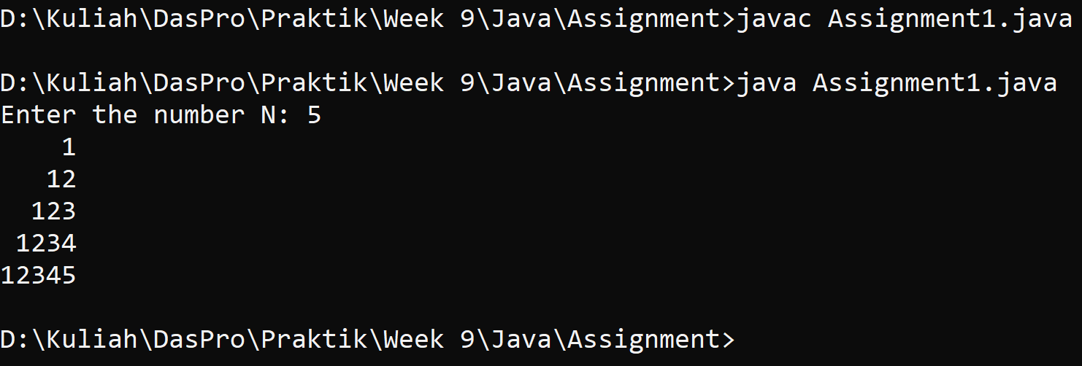
2. Create a program to print the star triangle view shown below based on the N input (minimum N value is 5). Example N = 7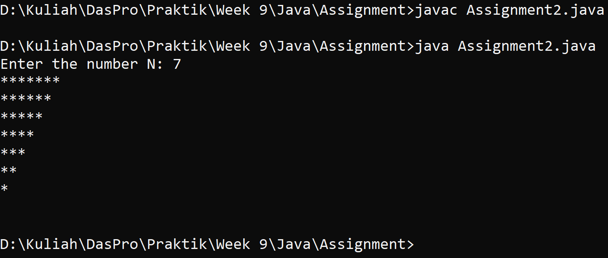
3. Create a program to print a square numeric display like the one below based on N input (minimum N value is 3). Example N = 3 and N = 5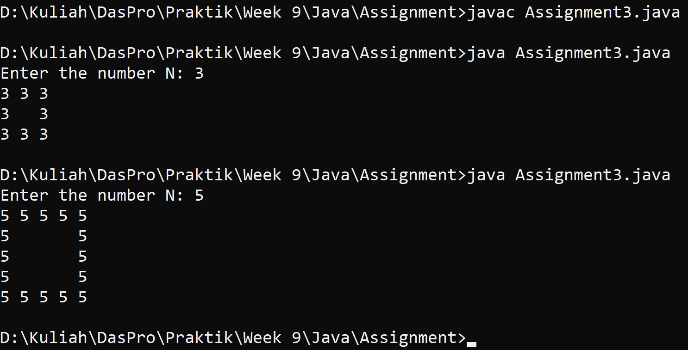
4. Create a program to print a square numeric display like the one below based on N input (minimum N value is 5). Example N = 5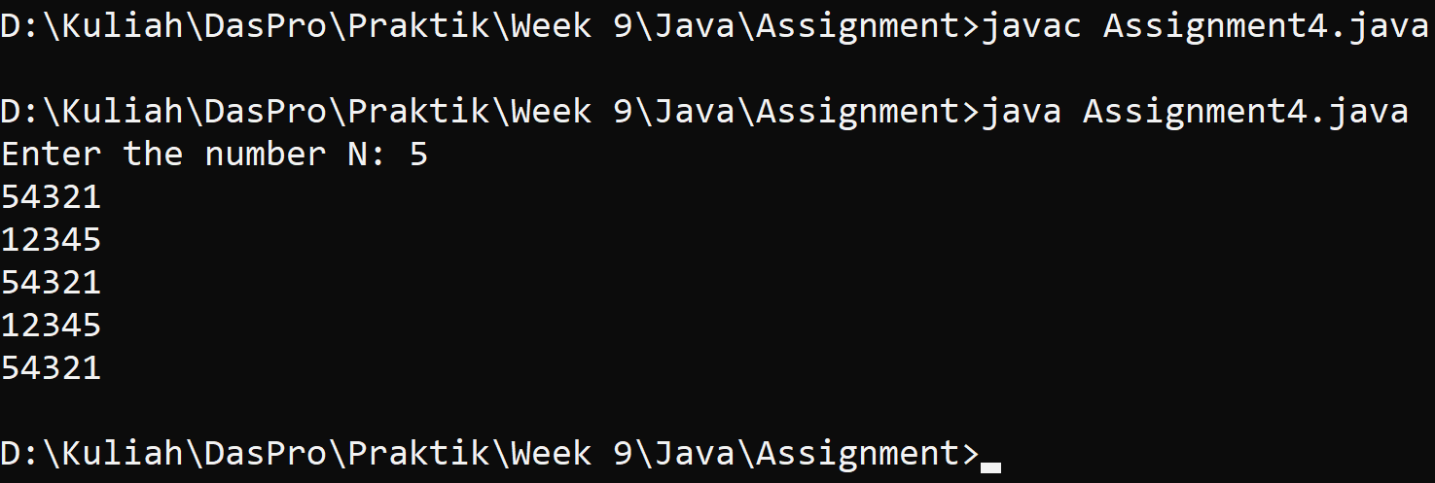

## Answer!

1. –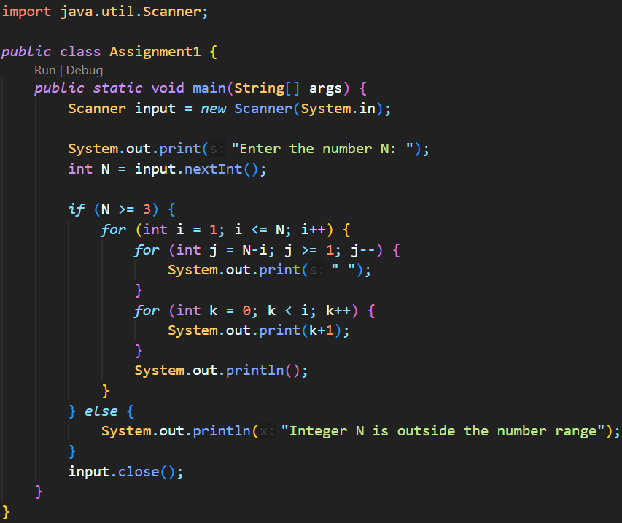
2. –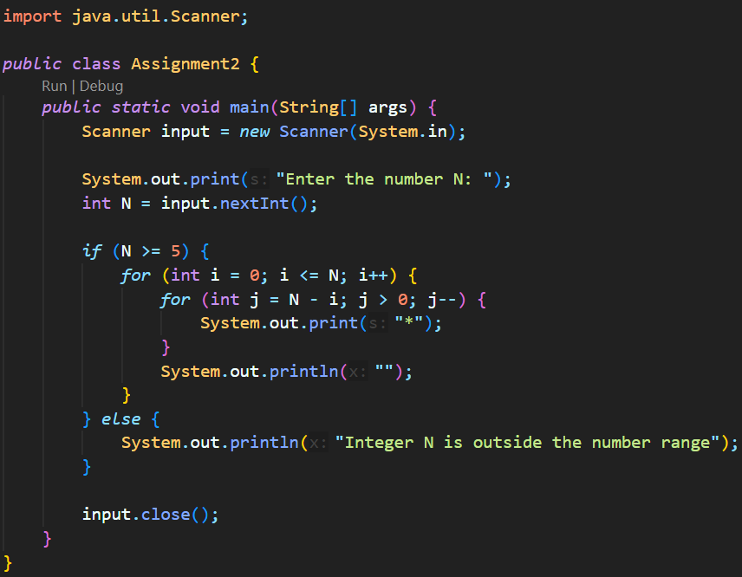
3. –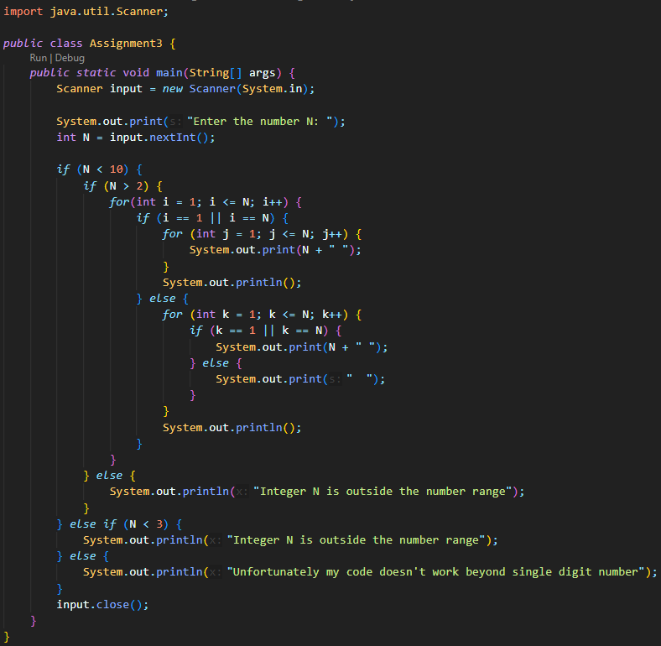
4. –